**MASS STORAGE SYSTEM (OPERATING SYSTEM )**

**MADE BY : ASHISH SHAH**

**MCA STUDENT NATIONAL INSTITUTE OF TECHNOLOGY WARAGAL**

**Q. Is disk scheduling, other than FCFS scheduling, useful in a single-user**

**environment? Explain your answer.**

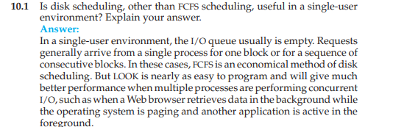

**Q.** **Explain why SSTF scheduling tends to favor middle cylinders over the**

**innermost and outermost cylinders.**

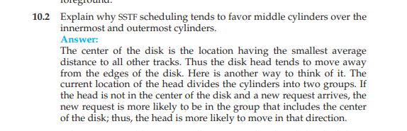

**Q. Why is rotational latency usually not considered in disk scheduling?**

**How would you modify SSTF, SCAN, and C-SCAN to include latency**

**Optimization**

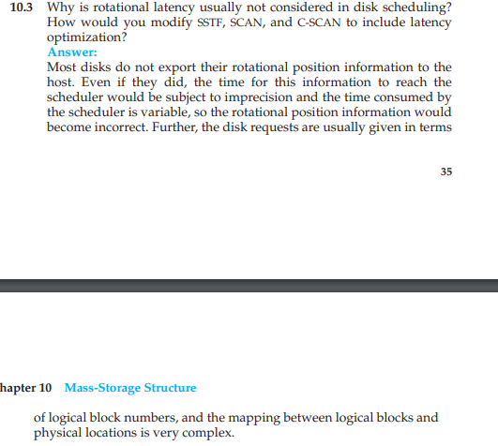

**QWhy is it important to balance file-system I/O among the disks and**

**controllers on a system in a multitasking environment?**

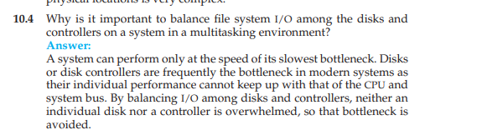

**QWhat are the tradeoffs involved in rereading code pages from the file**

**system versus using swap space to store them?**

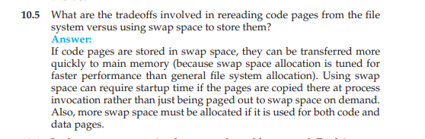

**Q. Is there any way to implement truly stable storage? Explain your**

**answer.**

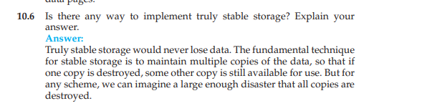

**Q.Could a RAID level 1 organization achieve better performance for read requests than a RAID level 0 organization (with nonredundant striping of data)? If so, how?**Ans : Yes, a RAID Level 1 organization could achieve better performance for read requests. When a read operation is performed, a RAID Level 1 system can decide which of the two copies of the block should be accessed to satisfy the request. This choice could be based on the current location of the disk head and could therefore result in performance optimizations by choosing a disk head that is closer to the target data.

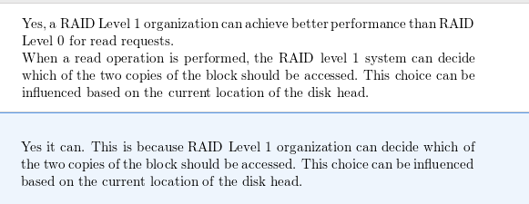

**Q.. It is sometimes said that tape is a sequential-access medium, whereas**

**a magnetic disk is a random-access medium. In fact, the suitability**

**of a storage device for random access depends on the transfer size.**

**The term “streaming transfer rate” denotes the rate for a data transfer**

**that is underway, excluding the effect of access latency. In contrast,**

**the “effective transfer rate” is the ratio of total bytes per total seconds,**

**including overhead time such as access latency.**

**Suppose we have a computer with the following characteristics: the**

**level-2 cache has an access latency of 8 nanoseconds and a streaming**

**transfer rate of 800 megabytes per second, the main memory has an**

**access latency of 60 nanoseconds and a streaming transfer rate of 80**

**megabytes per second, the magnetic disk has an access latency of 15**

**milliseconds and a streaming transfer rate of 5 megabytes per second,**

**and a tape drive has an access latency of 60 seconds and a streaming**

**transfer rate of 2 megabytes per second**

**a. Random access causes the effective transfer rate of a device to**

**decrease, because no data are transferred during the access time.**

**For the disk described, what is the effective transfer rate if an**

**average access is followed by a streaming transfer of (1) 512 bytes,**

**(2) 8 kilobytes, (3) 1 megabyte, and (4) 16 megabytes?**

**b. The utilization of a device is the ratio of effective transfer rate to**

**streaming transfer rate. Calculate the utilization of the disk drive**

**for each of the four transfer sizes given in part a.**

**c. Suppose that a utilization of 25 percent (or higher) is considered**

**acceptable. Using the performance figures given, compute the**

**smallest transfer size for disk that gives acceptable utilization.**

**d. Complete the following sentence: A disk is a random-access**

**device for transfers larger than bytes and is a sequentialaccess**

**device for smaller transfers.**

**e. Compute the minimum transfer sizes that give acceptable utilization**

**for cache, memory, and tape.**

**f. When is a tape a random-access device, and when is it a**

**sequential-access device?**

Solution : 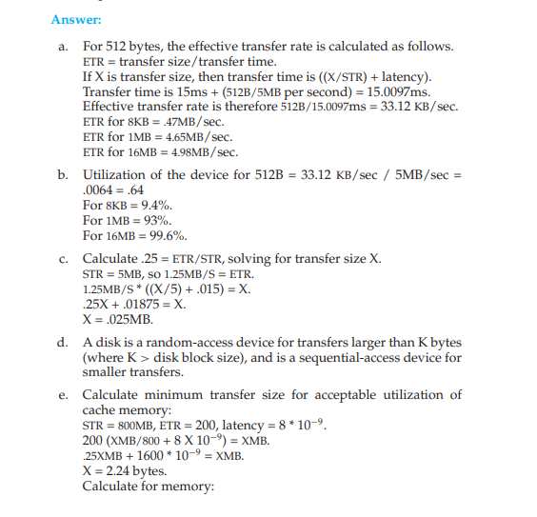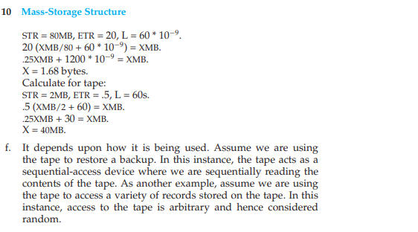

**Q.** 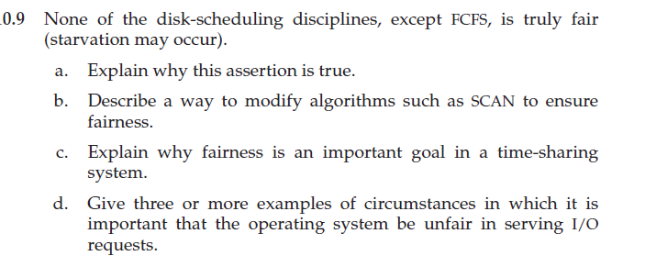

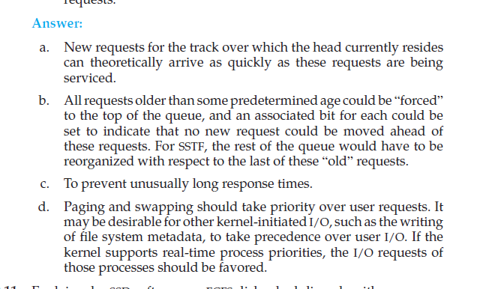

**Q. Explain why SSDs often use an FCFS disk-scheduling algorithm.**

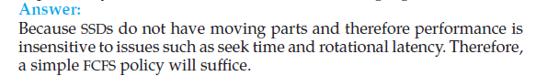

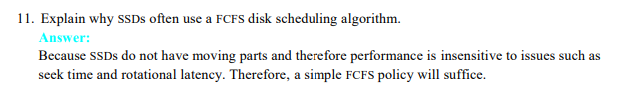

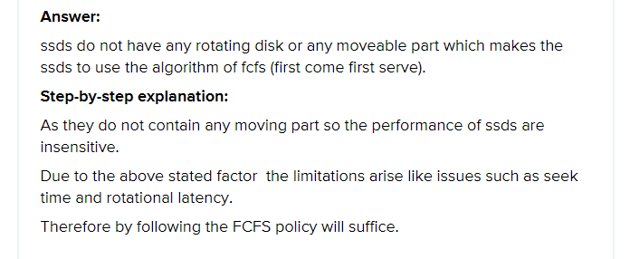

**Q. Suppose that a disk drive has 5,000 cylinders, numbered 0 to 4,999. The**

**drive is currently serving a request at cylinder 2,150, and the previous**

**request was at cylinder 1,805. The queue of pending requests, in FIFO**

**order, is:**

**2,069, 1,212, 2,296, 2,800, 544, 1,618, 356, 1,523, 4,965, 3681**

**Starting from the current head position, what is the total distance (in**

**cylinders) that the disk arm moves to satisfy all the pending requests**

**for each of the following disk-scheduling algorithms?**

**a. FCFS**

**b. SSTF**

**c. SCAN**

**d. LOOK**

**e. C-SCAN**

**f. C-LOOK**

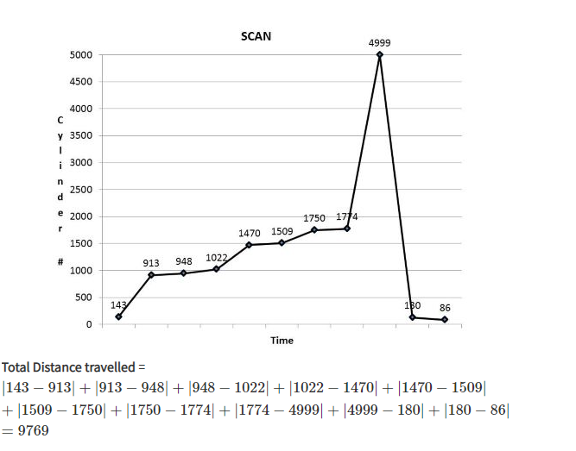

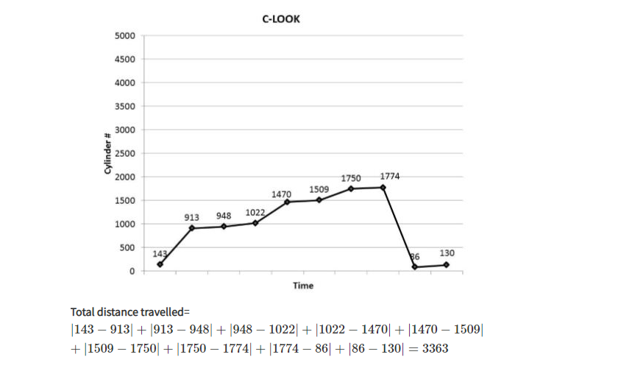

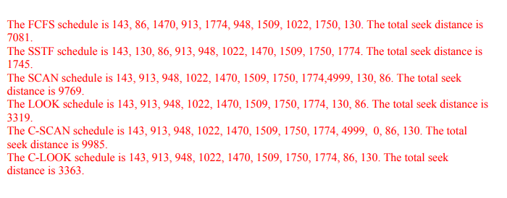

**Q.Elementary physics states that when an object is subjected to a constant**

**acceleration *a,* the relationship between distance *d* and time *t* is given**

**by *d* = 12**

***at*2. Suppose that, during a seek, the disk in Exercise 10.11**

**accelerates the disk arm at a constant rate for the first half of the seek,**

**then decelerates the disk arm at the same rate for the second half of the**

**seek. Assume that the disk can perform a seek to an adjacent cylinder**

**in 1 millisecond and a full-stroke seek over all 5,000 cylinders in 18**

**milliseconds.**

**a. The distance of a seek is the number of cylinders over which the**

**head moves. Explain why the seek time is proportional to the**

**square root of the seek distance.**

**b. Write an equation for the seek time as a function of the seek**

**distance. This equation should be of the form *t* = *x*+ *y***

**√**

***L*, where**

***t* is the time in milliseconds and *L* is the seek distance in cylinders.**

**c. Calculate the total seek time for each of the schedules in Exercise**

**10.11. Determine which schedule is the fastest (has the smallest**

**total seek time).**

**d. The percentage speedup is the time saved divided by the original**

**time. What is the percentage speedup of the fastest schedule over**

**FCFS?**

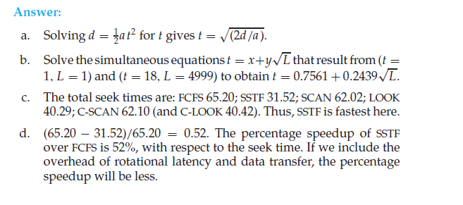

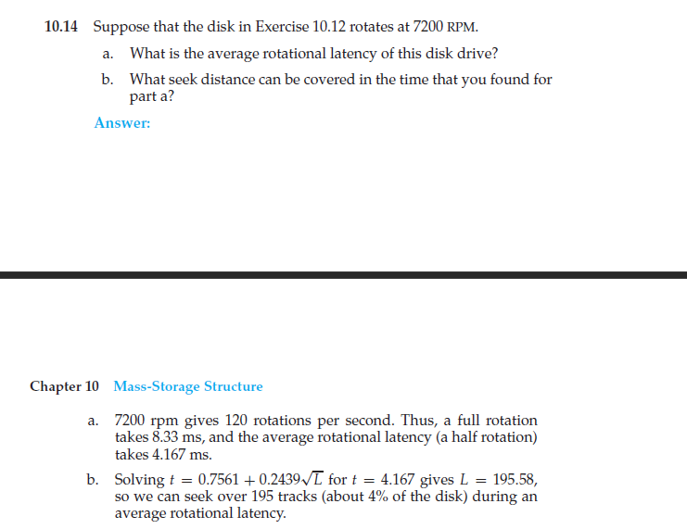

**Q .Describe some advantages and disadvantages of using SSDs as a**

**caching tier and as a disk-drive replacement compared with using only**

**magnetic disks.  
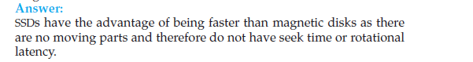**

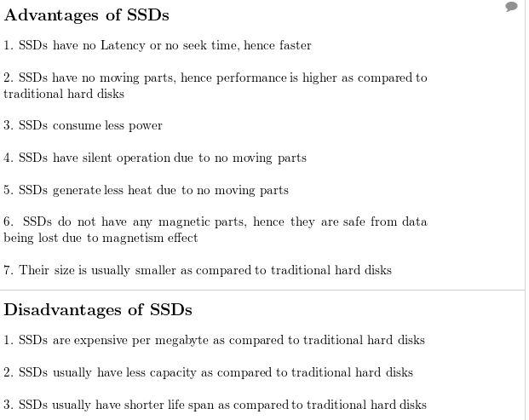

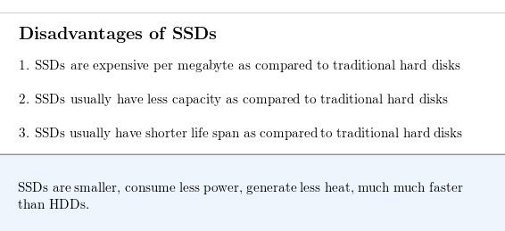

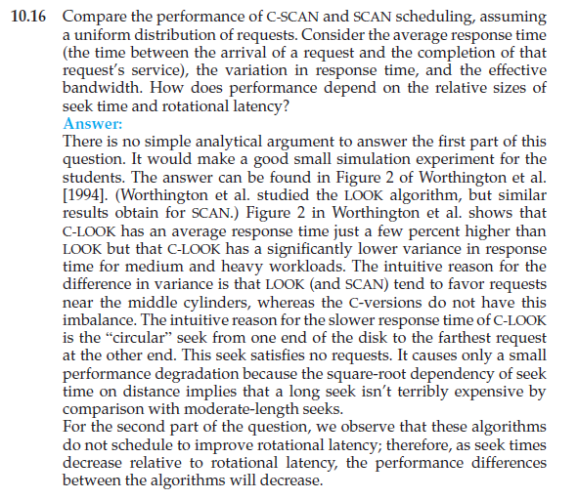

**Q,Requests are not usually uniformly distributed. For example, we can**

**expect a cylinder containing the file-system metadata to be accessed**

**more frequently than a cylinder containing only files. Suppose you**

**know that 50 percent of the requests are for a small, fixed number of**

**cylinders.**

**a. Would any of the scheduling algorithms discussed in this chapter**

**be particularly good for this case? Explain your answer.**

**b. Propose a disk-scheduling algorithm that gives even better performance**

**by taking advantage of this “hot spot” on the disk.**

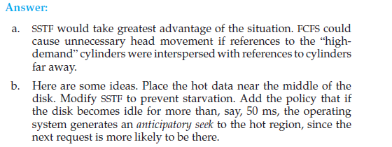

**Q.Consider a RAID level 5 organization comprising five disks, with the**

**parity for sets of four blocks on four disks stored on the fifth disk. How**

**many blocks are accessed in order to perform the following?**

**a. A write of one block of data**

**b. A write of seven continuous blocks of data**

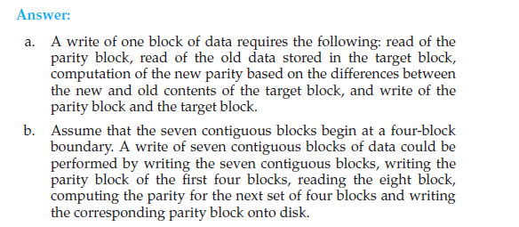

**QCompare the throughput achieved by a RAID level 5 organization with**

**that achieved by a RAID level 1 organization for the following:**

**a. Read operations on single blocks**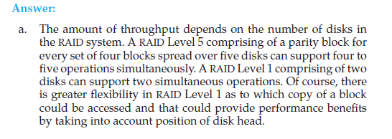

**b. Read operations on multiple contiguous blocks**

**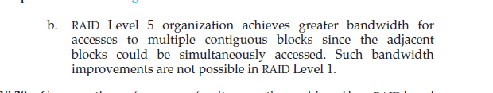  
Q. Compare the performance of write operations achieved by a RAID level**

**5 organization with that achieved by a RAID level 1 organization.**

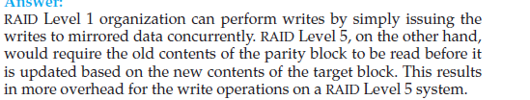

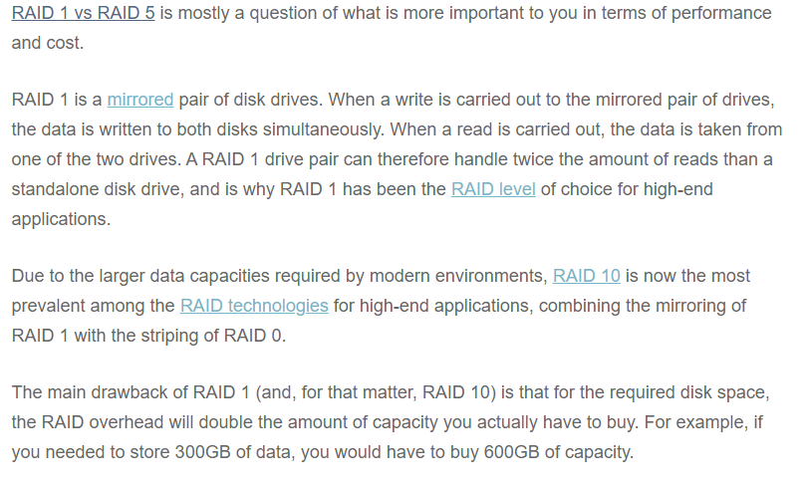

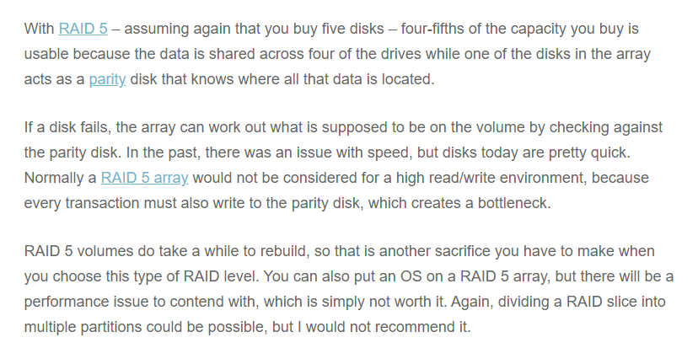

**Q. Assume that you have a mixed configuration comprising disks organized**

**as RAID level 1 and RAID level 5 disks. Assume that the system**

**has flexibility in deciding which disk organization to use for storing a**

**particular file. Which files should be stored in the RAID level 1 disks**

**and which in the RAID level 5 disks in order to optimize performance**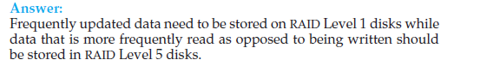

**http://ibgwww.colorado.edu/~lessem/psyc5112/usail/peripherals/disks/raid/**

